
The minutes of Satterthwaite Parish Council in the Parish Room, Satterthwaite on Monday 2nd March 2026 at 7.30 pm.
Agenda
Item |  | Additional  information
Opening Administration
1 | Welcome and Introductions  Apologies  Suzanne Pender  Emma Nield  David Robbens resigned from Parish Council therefore not present
2 | Declarations of interest  - To receive declarations by elected and co-opted members of disclosable pecuniary interests in respect of items on this agenda.  None
3 | Requests for Dispensations  - The clerk to report any requests received since the previous meeting for dispensations to speak and/or vote on any matter where a member has a disclosable pecuniary interest.  None
4 | Minutes  - To authorise the Chair to review and sign last meetings minutes on 19th Jan 2026 – approved as an accurate record | Minutes attached from January 2026
Matters for consideration
5 | Public participation  - To receive comments and representations from members of the public in relation to any item on the agenda  None present
6 | Updates on ongoing issues and actions from last meeting  Review of action log  - LDNPA and Dale Park caravan update – new structures been logged and visited by LDNAP – monitoring. Long standing caravan will be progressing to court hearing later this month.  - Playground quotes – Emma Nield is progressing.  - Zurich insurance – policy to be reviewed and amended by all Councillors.  - Observatory visit plans for community – to liaise with observatory for dates – likely next two weeks – will advertise once confirmed.  - Village Parking - to clarify gabion walls and surface – architects to clarify to LDNPA the details.  - Moor lane and motorcyclists – LDNPA suggested solutions, currently being improved for Cumbria way project – 16th March meeting, Gary to attend and input Parish Council views on wider issues with motorcyclists in forest.  - Standing Orders/Financial regs – agreed – will be uploaded to website prior to next meeting.  - Meeting with HIAMS – Suzanne Pender continuing to raise issues for local area.  - Community Governance response – further consultation planned for residents – CALC have advised we could request ‘informal grouping’ with Colton – Clerk will send formal letter to W&F.  - Internal auditor to be enlisted prior to AGAR – will confirm who in due course and enlist once end of year accounts ready.  - Formal complaint to Fibrus – Suzanne Pender raised on behalf of local Parishes.  - Complaint to W&F re community governance draft report – action to be closed (ongoing in separate log).  - AGAR to be completed after end of year accounts complete. | Action log
7 | Items for meeting not covered above  - White tailed Eagle project – further consultation planned but they are already being introduced in North Lakes prior to this closing – for formal complaint as already released in N Lakes incl social media – Clerk to write a formal complaint regarding undermining of consultation process, and concerns raised by local residents esp re: farms.  - Parish room map – update re: Community Governance Review – boundaries may change – to discuss with Parish Room Committee, but support plans for a map and CIS already contacted.
8 | Additional or urgent points to raise regarding Parish or Councillor matters  Resignation given by David Robbens (this was after formal agenda was published) – Clerks will notify elections team and position to go out to advert.
9 | Items for the Lengthsman  Tidy beeches area and remove branches  Drains Dale Park – between low and middle Dale, and bottom triangle before bridge
Planning
10 | Planning Consultations sought from Parish Council  - 7/2025/5659 1-5 Force Forge Cottages – supported  - 7/2025/5555 Bank Cottage Force Forge, installation of sewage treatment plant
Finance
11 | Accounts since last meeting  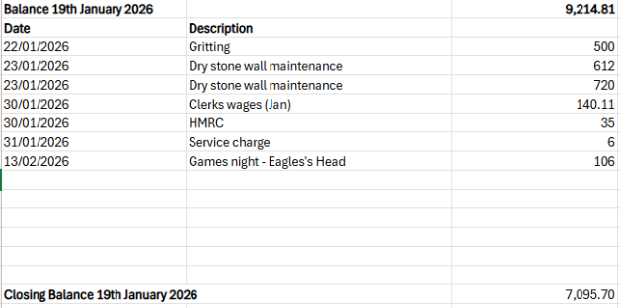Noted
12 | Precept setting - action complete
Key correspondence, consultations and reports not covered above
13 | White tailed Eagle project – further consultation planned but they are already being introduced in North Lakes prior to this closing – see item 7.
14 | Traffic regulations High Nibthwaite-Parkamoor route – support to close the route for motor vehicles and for farm and forestry access only – Clerk will feedback on consultation.
Council calendar
15 | Observatory visit date to be arranged  Communication will be sent out soon
Closing administration
16 | Agenda items for next meeting  Budget setting for year
17 | Next meeting date to be agreed  - 20th April 2026  - 8th June 2026 7:15 including AGM

